|  |
| --- |
|  |
| Foil Based Insulation Design for a Space Probe |
| ME223 Final Project |
|  |
| **Jackson Kyle and Bryan Knouse** |
| **5/3/2012** |

**ME 223 Final Project:**

**Designing Thermal Insulation for a Space Probe**

**Introduction:**

The purpose of this project is to provide the thermal design for a planned NASA probe to be sent to space. The design of the probe is required to adhere to several constraints:

* Maximum and minimum operating temperatures of the electronics (10 - 50°C)
* Minimum safe standby temperature (-10°C)
* Maximum and minimum heat generation from cockpit electronics (36 – 60 W)
* Probe has a pre-determined size (A­­­­s=118 m2)
* Probe has a given heat capacity (65000 J/K)

Our design is comprised of the following components

* Multilayered foil insulation with evacuated gaps between (ε = 0.04)
* Metal inner and outer walls of negligible thermal resistance (ε = 0.05 and 0.04, respectively)
* Uses only the heat from the electronics to maintain temperature
* A fan circulates the gases in the probe to effectively maintain the interior temperature at the interior wall temperature

The problem statement asks for the foil insulation to be designed in such a way that the cockpit constraints are met despite changing heat generation (within the given range). To do so, the insulation is constructed from a certain number of foil layers that will satisfy these conditions. Specifically, this project will answer **(1)** How many foil layers maintain cockpit temperature, **(2)** The individual temperatures of each layer and then the distribution of that temperature profile, **(3)** Behavior of cockpit with nearby states of insulation, and **(4)** How long the sensitive electronics will survive permanent damage if all heat generation ceases.

**Calculations:**

**Part 1:**

The governing equation for relating emissivity and temperature of each individual foil layer is shown below:

$$(1) \dot{q}= \frac{σ(T_{1}^{4}-T_{2}^{4})}{\frac{1}{ε_{1}}+\frac{1}{ε_{2}}-1}$$

At the surface of the space probe, we can find an equation for $\dot{q }$ such that:

$$\dot{q }= ε_{surface}σ{(T}_{surface}^{4}-T_{surround}^{4})$$

However, in space, assuming the temperature is 0 K (it is very close), $T_{surround}^{4}$ = 0, and the equation then becomes:

$$\dot{q }= ε_{surface}σT_{surface}^{4}$$

Combining $σT_{surface}^{4}$ into one variable, $X_{surface}$, the equation for $\dot{q }$ simplifies to:

$\dot{q }= ε_{surface}X_{surface}$

With this information, we can simplify the first $\dot{q }$ equation given, as well. Parameterizing with $X$ notation and changing the emissivities in the denominator to one variable, $k$, we result in three equations.

The relation between the inner wall of the probe and the innermost layer of foil:

$$\left(A\right) \dot{q }= \frac{X_{in}-X_{1}}{k_{in}}$$

The relation between the innermost and outermost foil layers:

$$\left(B\right) \dot{q}= \frac{X_{1}-X_{n}}{(n-1)k_{f}}$$

The relation between the outer wall of the probe and the outermost layer of foil:

$$(C) \dot{q }= \frac{X_{n}-X_{surface}}{k_{out}}$$

Where:

$$k_{in}=\frac{1}{\frac{1}{ε_{in}}+\frac{1}{ε_{f}}-1}{ k}_{f}=\frac{1}{\frac{2}{ε_{f}}-1}{ k}_{out}=\frac{1}{\frac{1}{ε_{f}}+\frac{1}{ε_{out}}-1}$$

To determine the number of foil layers and solve the first requirement, the above equations must be solved to find a relation between $\dot{q }$ and $T_{in}^{4}$. To start, **(C)** is solved for $X_{n}$ and $\frac{\dot{q }}{ε_{surface}}$ is substituted for $X_{surface}$.

$\dot{q }\left[k_{out}\right]=X_{n}- \frac{\dot{q }}{ε_{surface}}$ $\dot{q }\left[k_{out}+ \frac{1}{ε_{surface}}\right]=X_{n}$

This is the general procedure followed through equations **(B)** and **(A)**. Substituting $X_{n}$ into equation **(B)** and solving for $X_{1}$ produces another equation similar the one above. Again, repeating the calculation and substituting $X_{1}$ into equation **(A)** ends in a relation between $\dot{q }$ and $X_{in}$, which is equal to $σT_{in}^{4}$, which is exactly what was needed. The result is shown below:

$$\dot{q }= {\frac{σ}{85.67+49n}T}_{in}^{4}$$

**Part 2:**

To find the temperature of each individual foil layer, the equation **(1)** is applied to both walls, and all interior foil layers.

Using MATLAB, the numerous iterations can be completed on a computer providing tabled data with the temperatures of each layer. The code for this is in appendix A.

**Part 3:**

Exploring the system’s behavior adding or subtracting one layer from the insulation is shown in the results section. MATLAB was also used for this part, beginning with the interior temperature of the probe and using equation (1) to solve outward for each case of one more and one less layer of foil than our optimized design. A table of minimum and maximum temperatures for ±1 and 2 layers and plots for ±1 layer are in the results section. The code is also in appendix A for this part.

**Part 4:**

The final calculation of our design is finding the time it takes the interior of the probe to reach the minimum standby temperature of the electronics (10°C). While in standby, the electronics produce a negligible amount of heat. This problem is then a transient cooling problem.

The transient cooling of the probe can be represented as a fairly simple differential equation shown here:

$$C_{probe}\frac{dT}{dt}={-A}_{s}\dot{q}$$

We know $\dot{q}$ as a function of the probe’s inner temperature from the boxed equation in part 1 of the calculations. By substituting the function of $\dot{q}(T)$ into the differential, it becomes a separable differential equation that we can solve analytically:

$$C_{probe}\frac{dT}{dt}={-A}_{s}{\frac{σ}{(85.67+49n)}T}_{in}^{4}$$

By combining all of the constants into one constant, the differential becomes much simpler to work with and input into MATLAB:

$\frac{dT}{dt}=βT_{in}^{4}$ $β= \frac{-A_{s}}{C_{probe}}\frac{σ}{(85.67+49n)}$

Here the differential is separated into an integration friendly form and subsequently is integrated to give us a relationship between inner temperature and time for a given number of foil layers:

$ʃ\frac{dT}{T_{in}^{4}}=ʃβdt$ $- \frac{1}{3T_{in}^{3}}+C=βt$

The constant of integration C for each initial temperature can be found by solving for boundary conditions at $t=0$ for both $T_{in}= T_{max}, T_{min}$ where:

$$\frac{1}{3{T_{in}}^{3}}=C_{max},C_{min}$$

Using this constant of integration and rearranging the integrated differential gives us inner temperature of the probe explicitly related to time in seconds as seen here:

$$T_{in}=\sqrt[3]{\frac{1}{3(C_{max,min}-βt)}}$$

Again, using MATLAB to iterate the solution, we tried increasing values of *t* until Tin was less than or equal to -10°C. The code for this part is in appendix B.

**Results:**

**Part 1 & 2:**

The calculations performed in part 1 resulted in $n$ = 23 layers of foil. This is the optimum temperature where the interior will remain within the specified operating conditions.

|  |  |  |
| --- | --- | --- |
| **Number of Layers** | **Maximum Temperature (oC)** | **Minimum Temperature (oC)** |
| 1 | -86.730 | -109.080 |
| 2 | -71.690 | -95.850 |
| 3 | -59.420 | -85.050 |
| 4 | -48.960 | -75.840 |
| 5 | -39.790 | -67.770 |
| 6 | -31.590 | -60.550 |
| 7 | -24.150 | -54.000 |
| 8 | -17.320 | -47.990 |
| 9 | -11.000 | -42.430 |
| 10 | -5.100 | -37.240 |
| 11 | 0.430 | -32.370 |
| 12 | 5.640 | -27.780 |
| 13 | 10.580 | -23.440 |
| 14 | 15.270 | -19.310 |
| 15 | 19.750 | -15.370 |
| 16 | 24.020 | -11.600 |
| 17 | 28.120 | -8.000 |
| 18 | 32.060 | -4.530 |
| 19 | 35.860 | -1.190 |
| 20 | 39.510 | 2.030 |
| 21 | 43.050 | 5.140 |
| 22 | 46.470 | 8.150 |
| 23 | 49.780 | 11.060 |
| 24 | 52.990 | 13.890 |
| 25 | 56.110 | 16.640 |

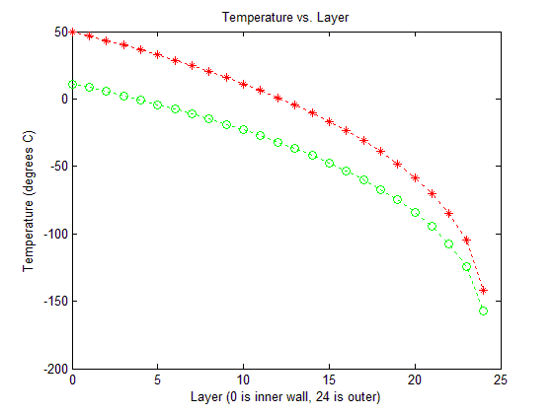

**Part 3:**

Neighboring states of the insulation are shown below, with the accompanying plots. This is the same data from parts 1 & 2, as the states could easily be found during those initial calculations.

|  |  |  |
| --- | --- | --- |
| **Number of Layers** | **Maximum Temperature (oC)** | **Minimum Temperature (oC)** |
| 21 | 43.050 | 5.140 |
| 22 | 46.470 | 8.150 |
| 23 | 49.780 | 11.060 |
| 24 | 52.990 | 13.890 |
| 25 | 56.110 | 16.640 |

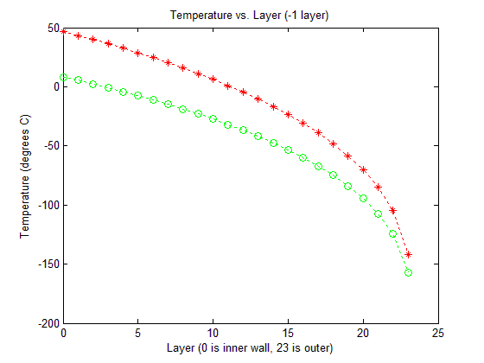

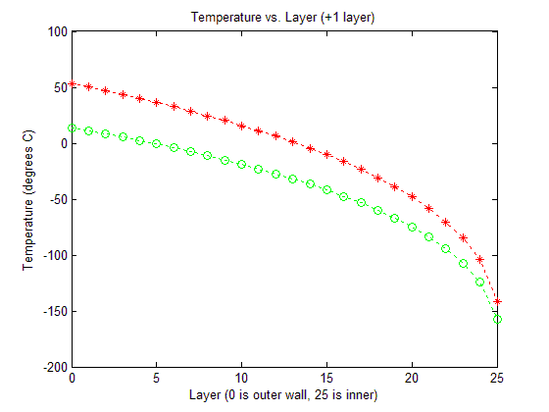

**Part 4:**

The final step was to calculate the amount of time required for the probe to lose heat to the critical level while in standby mode, -10°C. From the minimum cockpit temperature, it would take 709 minutes, or 11.82 hours. From the maximum cockpit temperature, it would take 1653 minutes, or 27.55 hours. Temp. vs. Time graphs are shown below.

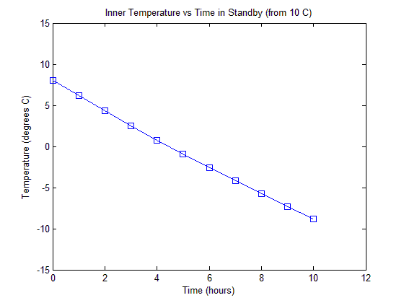

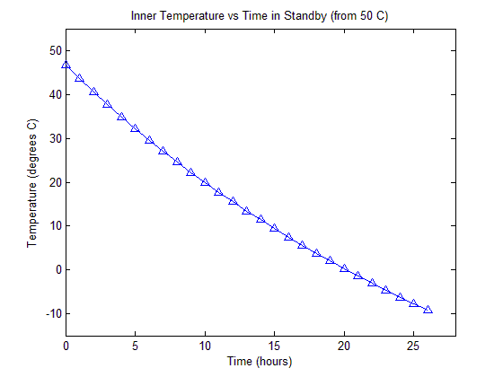

**Summary:**

With the information provided by the contest along with the design goals set forth in the project overview, we were able to formulate an insulation system that satisfies the design constraints of the probe. By finding a relationship between the interior temperature of the probe and the heat flow leaving the probe via radiation in steady state, it was possible to iterate on designs of various numbers of foil layers. Using the minimum and maximum heat produced by the electronics on board, we have determined that our foil insulation requires 23 layers to be effective. It uses enough layers to prevent the temperature from going below 10°C while the electronics produce minimal heat and it is few enough layers that the temperature inside the probe won’t exceed 50°C with the electronics producing their maximum heat output.

Using the equation for radiation heat transfer between two flat plates, the temperature distribution through each design’s layers can be found. It shows the 4th order nature of the relationship between heat flow and temperature difference.

In exploring the designs with one more layer and one less layer, it is shown that neither design fits the requirements. One more layer gets too hot at maximum heat flow and one less layer gets too cold at minimum heat flow. Thus the optimal design can only be that which we found in part 1, a design with 23 layers of foil.

Our final design assessment was to calculate the transient cooling characteristics of our design with the electronics in standby mode, producing no more heat. By solving a differential equation representative of the transient cooling behavior, we were able to iterate the solution and get a temperature versus time curve that shows how long it takes to cool below the critical temperature of -10°C.

**References:**

Professor Al Clark – consulted on mathematics

Appendix A

function ME223_Project_2

%ME223 Design project - May 2012%

%Jackson Kyle and Bryan Knouse%

close all

clear all

clc

%Emissivities of outer/inner wall and foil%

ein=0.05; ef=0.04; eout=0.03;

kin=(1/ein)+(1/ef)-1; kf=(2/ef)-1; kout=(1/eout)+(1/ef)-1;

%Given quantities and constants%

Tmax=50+273.15; Tmin=10+273.15;

Qmin=36; Qmax=60;

As=118;

qmin=Qmin/As; qmax=Qmax/As;

sigma=5.67*10^-8;

n=25;

Tinmax=zeros(1,n);

for i=1:n

Tinmax(1,i)=((qmax*(85.67+49*i))/sigma)^(1/4);

fprintf('The maximum temperature with %i layers is %4.4f degrees C\n',i, Tinmax(1,i)-273.15)

end

Tinmin=zeros(1,n);

for i=1:n

Tinmin(1,i)=((qmin*(85.67+49*i))/sigma)^(1/4);

fprintf('The minimum temperature with %i layers is %4.4f degrees C\n',i, Tinmin(1,i)-273.15)

end

foils=zeros(2,1);

for i=1:n

if Tinmax(i)>Tmax

fprintf('\nThe maximum number of foil layers is %i \n',i-1)

foils=i-1;

break

end

end

for i=1:n

if Tinmin(i)>Tmin

fprintf('The minimum number of foil layers is %i \n',i)

if foils==i

foils=i;

else

break

end

break

end

end

fprintf('\n**The optimal number of foil layers is %i**\n',foils)

Xdist=zeros(26,6);

Xdist(1,1)=sigma*Tinmax(foils)^4;

Xdist(1,2)=sigma*Tinmax(foils-1)^4;

Xdist(1,3)=sigma*Tinmax(foils+1)^4;

Xdist(1,4)=sigma*Tinmin(foils)^4;

Xdist(1,5)=sigma*Tinmin(foils-1)^4;

Xdist(1,6)=sigma*Tinmin(foils+1)^4;

Xdist(2,1)=Xdist(1,1)-qmax*kin;

Xdist(2,2)=Xdist(1,2)-qmax*kin;

Xdist(2,3)=Xdist(1,3)-qmax*kin;

Xdist(2,4)=Xdist(1,4)-qmin*kin;

Xdist(2,5)=Xdist(1,5)-qmin*kin;

Xdist(2,6)=Xdist(1,6)-qmin*kin;

for i=2:foils

Xdist(i+1,1)=Xdist(i,1)-qmax*kf;

Xdist(i+1,4)=Xdist(i,4)-qmin*kf;

end

for i=2:foils-1

Xdist(i+1,2)=Xdist(i,2)-qmax*kf;

Xdist(i+1,5)=Xdist(i,5)-qmin*kf;

end

for i=2:foils+1

Xdist(i+1,3)=Xdist(i,3)-qmax*kf;

Xdist(i+1,6)=Xdist(i,6)-qmin*kf;

end

Xdist(foils+2,1)=Xdist(foils+1,1)-qmax*kout;

Xdist(foils+1,2)=Xdist(foils,2)-qmax*kout;

Xdist(foils+3,3)=Xdist(foils+2,3)-qmax*kout;

Xdist(foils+2,4)=Xdist(foils+1,4)-qmin*kout;

Xdist(foils+1,5)=Xdist(foils,5)-qmin*kout;

Xdist(foils+3,6)=Xdist(foils+2,6)-qmin*kout;

figure(1)

Tdistmin=abs(Xdist(:,4)./sigma).^(1/4)-273.15;

plot(0:foils+1,Tdistmin(1:foils+2),'g:o')

hold on

Tdistmax=abs(Xdist(:,1)./sigma).^(1/4)-273.15;

plot(0:foils+1,Tdistmax(1:foils+2),'r:*')

title('Temperature vs. Layer')

xlabel('Layer (0 is outer wall, 24 is inner)')

ylabel('Temperature (degrees C)')

fprintf('\nThe maximum temperature at our design is %3.3f \n',Tdistmax(1))

fprintf('The minmum temperature at our design is %3.3f \n',Tdistmin(1))

figure(2)

Tdistmin=abs(Xdist(:,5)./sigma).^(1/4)-273.15;

plot(0:foils,Tdistmin(1:foils+1),'g:o')

hold on

Tdistmax=abs(Xdist(:,2)./sigma).^(1/4)-273.15;

plot(0:foils,Tdistmax(1:foils+1),'r:*')

title('Temperature vs. Layer (-1 layer)')

xlabel('Layer (0 is outer wall, 23 is inner)')

ylabel('Temperature (degrees C)')

fprintf('The maximum temperature of our design minus one layer is %3.3f \n',Tdistmax(1))

fprintf('The minimum temperature at our design minus one layer is %3.3f \n',Tdistmin(1))

figure(3)

Tdistmin=abs(Xdist(:,6)./sigma).^(1/4)-273.15;

plot(0:foils+2,Tdistmin,'g:o')

hold on

Tdistmax=abs(Xdist(:,3)./sigma).^(1/4)-273.15;

plot(0:foils+2,Tdistmax,'r:*')

title('Temperature vs. Layer (+1 layer)')

xlabel('Layer (0 is outer wall, 25 is inner)')

ylabel('Temperature (degrees C)')

fprintf('The maximum temperature of our design plus one layer is %3.3f \n',Tdistmax(1))

fprintf('The minimum temperature at our design plus one layer is %3.3f \n',Tdistmin(1))

Appendix B

function ME223_Project_2_Pt4

%ME223 Design project - May 2012%

%Jackson Kyle and Bryan Knouse%

close all

clear all

clc

%Emissivities of outer/inner wall and foil%

ein=0.05; ef=0.04; eout=0.03;

kin=(1/ein)+(1/ef)-1; kf=(2/ef)-1; kout=(1/eout)+(1/ef)-1;

%Given quantities and constants%

Tmax=50+273.15; Tmin=10+273.15;

Qmin=36; Qmax=60;

As=118;

qmin=Qmin/As; qmax=Qmax/As;

sigma=5.67*10^-8;

C=65000;

n=23;

B=-As*sigma/(C*(85.67+49*n));

cmax=1/(3*Tmax^3);

cmin=1/(3*Tmin^3);

Tlow=Tmin;

t=1;

while Tlow>=263.15

Tlow(t)=(1/(3*(cmin-B*t*60)))^(1/3);

t=t+1;

end

tmin=t-1;

hmin=tmin/60;

Thigh=Tmax;

t=1;

while Thigh>=263.15

Thigh(t)=(1/(3*(cmax-B*t*60)))^(1/3);

t=t+1;

end

tmax=t-1;

hmax=tmax/60;

Thighh(1)=Thigh(1);

n=61;

while n<=tmax

Thighh((n-1)/60)=Thigh(n);

n=n+60;

end

Tlowh(1)=Tlow(1);

n=61;

while n<=tmin

Tlowh((n-1)/60)=Tlow(n);

n=n+60;

end

figure(1)

plot(0:length(Thighh)-1,Thighh,'-^')

axis([0 28 260 325])

title('Inner Temperature vs Time in Standby (from 50 C)')

xlabel('Time (hours)')

ylabel('Temperature (degrees C)')

figure(2)

plot(0:length(Tlowh)-1,Tlowh,'-s')

axis([0 12 260 285])

title('Inner Temperature vs Time in Standby (from 10 C)')

xlabel('Time (hours)')

ylabel('Temperature (degrees C)')

fprintf('The transient solution for 10 degrees C is %i minutes or %3.2f hours\n',tmin,hmin)

fprintf('The transient solution for 50 degrees C is %i minutes or %3.2f hours\n',tmax,hmax)